Template for English CV 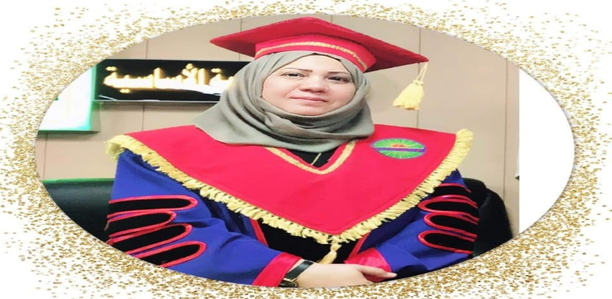
Personal Data:
- Name: Fatima Rahim Abdul Hussein
- Gender: female
- Marital status: single
- Date of birth: 1970
- Address: Iraq / Misan
- Mobile o7705548665
- Email: F.IQ777@yahoo.com
8.Email: F.IQ777@uomisan.edu.iq
Academic achievements and Qualifications: (staring from the most recent degree
1. B.A English Language, Education College of Ibn rushed, University of Baghdad 1998-1999.
2 M.A. In English language College of Education/ Ibn Rushed, University of Baghdad 2000-2002
3. PH.D. In English language, College of Education/ Ibn Rushed, University of Baghdad 2008-20012
Experiences: (staring from the most recent position), please mention Year, Position and Place
1. Head of English Department 2012-2015
2. Lecturer of English Language in the University of Imam Al-sadiq period2005-2014
3. Lecturer of English Language in the University of Wasit in 2005-2006.
4. Lecturer of English Language in the University of Imam Al-Al-kadhim period20014-2016
5. Lecturer of English Language in the University of Thiqar and university of misan for
teaching M.A and DR.students for engineering and sciences and physical sport and basic education colleges Students in 2016/2017/2018/209.
6. Lecturer of English Language in the University ofeducation for teaching M.A students
in applied linguistics and psycholinguistics in 2017/2018/2019.
7. Having appreciation certificate in Methods of Teaching in 2006-2007 from Lebanon.
8. Having appreciation certificate in Planning 2011-2012 from China .
9. Having appreciation certificate in strategic Planning 2015-2016 from Turkey.
10. Having appreciation certificate in Technology(digital age ) 2013-2014from America.
11. participated in the role global in Italy and certification has been awarded to journalists.
12 Supervisoring on many thesis of M.A Basic Education College Students.
13. Activitist woman in orginazation of Civil society
Languages:
1.English Language
2.Arabic Language
Published articles, papers and researches: please mention date, title and place of publication
1."Difficulties faced by Basic Education College Student in Essay Writing" Journal of Misan Researches. Vol. (2) No. (3) 2006.
2."Assessment of the Techniques used in Teaching English syllabus of Fifth Grade at primary schools" Journal of Misan Researches. Vol. (3) No. (5) 2006.
3.Evaluating the Professional Efficiency of primary school teachers in teaching RECI Book I. Journal of Educational and Psychological Researches.N12 7006.
4- the Effect of Autonomous Learning Programme on EFLl college Students’Perfomance in Writing .Journal . Journal of Educational and Psychological Researches No. (525)2011
5- The Impact of practicing autonomy on the writing proficiency of Iraqi college efl learners.

6- Analyzing the Errors Made by EFL College Students in ‘Verb to be’ at Recognition and Production levels Misan Journal for Academic Studies Vol. 11 No. 21 December (2012)

ISSN: 1994697X Year: 2012 Volume: 11 Issue: 21 Pages: 36-61 ,Publisher: Misan University
7-Comprehension and Production of Metaphor: Evidence from Horoscopes Translation
8-Investigating the Relationship between the Anxiety and Reading Comprehension and its Impact on Preparatory Schools Students' Performance in Misan. Journal of Mosul Researches. issn :1992-7452 No.6/59, 20014.
9- Investigating EFL College Teachers' and Learners’ Attitudes toward Using Authentic Reading Materials in Misan. Journal of Language Teaching and Research (JLTR, ISSN 1798-4769)
Copyright © 2015-2019 ACADEMY PUBLICATION — All Rights Reserved
10- The Effect of the Directed Reading – Thinking Activity on EFL Students 'Reading Comprehension.
11.Investigating Iraqi EFLCollege Teachers’Attitudes TowardsPracticing Critical Friends Groups Model (CFGS) ,International Journal of Multidisciplinary Research .Vol. Iv, Issue 7, November 2015.
22. Investigating Iraqi Teachers' Attitudes toward Using TPR as a Teaching Method for '' Iraq Opportunities textbook'' at Primary School. The International Journal Of Humanities & Social Studies (ISSN 2321 – 9203). www.theijhss.com. December, 2015

13 .The Effectiveness of Using YouTube Video on EFL Iraqi College Students' Performance in Grammar at Missan University Global Research & Development Services19-novmber -2016

14. Investigating Iraqi EFL College Students' Attitude towards Using Cooperative Learning Approach in Developing Reading Comprehension Skill ISSN 1798-4769 .Journal of Language Teaching and Research, Vol. 8, No. 6, pp. 1073-1080, November 2017 DOI: http://dx.doi.org/10.17507/jltr.0806.07

15. Four Comprehension Strategies of Reciprocal Teaching Enhancing Students’ Achievement in Reading Comprehension.The Third International Conference on Current Issues of Languages, Dialects and Linguistics (WWW.LLLD.IR) & The Fifth National Conference on English Studies and Linguistics (WWW.ELTL.IR), 31 January-1February 2019, Iran-Ahwaz, Book of Abstracts
16. THE EFFECT OF USING INDEX CARD GAMES ON IRAQI EFL PUPILS' PERFORMANCE IN CONVERSATION Sci.Int.(Lahore),31(1)B,87-91,2019 ISSN 1013-5316;CODEN: SINTE 8 87 (SCOPUS)

17. Finger Family Collection YouTube Videos Nursery Rhymes Impact on Iraqi EFL Pupils' Performance in Speaking Skills. Opción, Año 34, Especial No.17 (2018): 452-474
ISSN 1012-1587/ISSNe: 2477-9385(SCOPUS)
18 .The Effectiveness of Using Interactive Electronic Whiteboards( IEWB) in English Language Classroom , Revista de Filosofia Journal,ISSN 0798-1171, Universidad del Zulia(SCOPUS)
19. Dictogloss as a Technique to Raise EFL College Students’ Knowledge
of Grammar, Writing and the Comprehension of MeaningInternational Journal of English Linguistics; Vol. 9, No. 1; 2019 ISSN 1923-869X E-ISSN 1923-8703Published by Canadian Center of Science and Education 29)(Clarivate )

20. The Use of Context in Teaching Grammar and Its Influence on EFL Secondary School Students' Achievement in Grammar Rules in ICQH2018 International Conference on Quality in Higher Education, İstanbul- TURKEY, December 5-7, 2018
21.The Effect of Using Literature Circles(LC) Strategy on Students' Achievement in Literature Spots For " Iraq Opportunities textbook "21. AL-USTATH Special issue of the international scientific conference ( 2016 M- 1437)

Conferences and scientific activities: (if available)
1.Sharing with scientific conferences inside and outside Iraq.
2 - participated in the role global in Italy and certification has been awarded to journalists.
3 - Attending a special workshop introducing the new curriculum for English language sections of non- dedicated to the study of English in the College of Basic Education , Education and other faculties commensurate with the vocabulary approach the university and the universities of Iraq and held a workshop for new Iraqi Cutting Edge in Lebanon , and I have got a certificate of appreciation.
4 . Participated in the training course for the development and implementation of education policies in Iraq for the period from 14-10 to 2-11-201210 in the College of Teacher Education , ZhejiangNormalUniversity / china
5. Participated in the training course for the development and implementation of education in the Digital age – a multi- Regional Project in USA (International Visitor Leadership Program )for the period from 3 to 21 November2014.
Computer Skills
1- Good user in Microsoft office in 2007.
2- Good user in international network for information (Internet).

