Put the title of the paper here in font Arial,
size 16pt, centered, length up to 2 lines
First + Middle (initial) + Last name∗1(Superscript―*: Corresponding, 1: affiliation),
Sullivan T. Smith^{*2}, Tanaka Ikarashi¹ and Ahmed M. Mohamed²

¹Affiliation (Department, Institute, Address, Country) with font Arial, size 10pt
²Department of Civil Engineering, Korean Advanced Institute for Science and Technology,
291 Daehak-ro, Yuseong-gu, Daejeon 305-701, Republic of Korea
*Corresponding author E-mail: email address

(Received keep as blank, Revised keep as blank, Accepted keep as blank )

Abstract: This paper aims to study the effect of concrete confining using a new style of internal closed stirrups and longitudinal steel bars along with the middle third of the beam length of the beam-column joints……………….

Keywords: beam-column joint; monotonic load; steel fiber; concrete compressive

1. Introduction
Normally, strong winds have been associated with two types of wintyphoon-proneprone regions. The first one is natural nature wind, and the other one is typhoon, o,r say severe tropical cyclones [1]. Many investigations about the vibration and buckling (static stability) characteristics of frames of various types have been carried and out have studied the elastic critical loads for plane frames by using the transfer matrix method[2]. A general digital computer method has been described by Cheng and Xu (2012) ……

2. Section title: Level 1
The system examined, shown schematically in Fig. 1, is a beam of variable cross-section, carrying a so called heavy tip mass M. Its mass moment of inertia with respect to the perpendicular axis at the centroid S is denoted by J_{S}. The publications[2-4] are considered also with rotating beams in which nonlinear oscillations are investigated. Analytical and experimental investigations on vibrating frames carrying concentrated masses with frame characteristics have been studied using analytical solutions and the finite element method [5]. ……

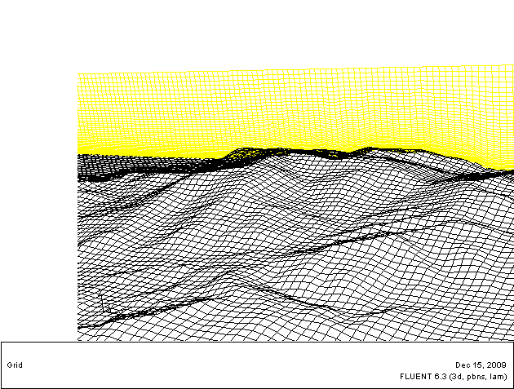
Fig. 1 Mesh grid of topographic model

2.1 Numerical simulation procedure
One can write the extended form of the Hamilton’s Principle with the notations used in the present study as[6]……
(1)
In consideration of different 10m height wind speed v10 and the power law exponent index α results shown in Table 2, the representative upstream typhoon wind fields at different directions used as the input data for training ANN model are determined, which is shown in Tables 1-2.……

3. Section title: Level 1
A finite element model is developed to represent a cracked beam element of length d and the crack is located at a distance d₁ from the left end of the element as shown in Figs. 2-3. Substituting Eqs. (3)-(4) in Eq. (7) yields the general equation for the local compliances as follows (considering that all K’s are independent of η; η: see Figs. 2(a)-(b)). In this regard, the circular area taking the bridge as a center with a proper radius shall be considered (see Fig. 1 and 3).…...

Table 1 Caption
 |  | Intact | DI | D2 | Intact | DI | D2
OF-1* | Mean | 2.63 | 2.62 | 2.53 | 3.34 | 2.67 | 2.46
OF-1* | SD | 0.041 | 0.369 | 0.123 | 0.290 | 0.444 | 0.207
OF-3 | Mean | 23.39 | 23.24 | 22.55 | 23.63 | 23.12 | 22.73
OF-3 | SD | 0.021 | 0.161 | 0.161 | 0.042 | 0.251 | 0.213
*OF-1: Observed Frequency for 1st mode; OF-3: Observed Frequency for 3rd mode
(a) Wind speed profile | (b) Wind direction profile
Fig. 2 ANN model output training data for upstream typhoon wind field coming from N direction with exponent 0.22

4. Section title: Level 1

4.1 Subtitle: Level 2

4.1.1 Subtitle: Level 3
On the day of the beam test, the respective control cylinders were capped and tested in compression to determine the compressive strength of concrete[7]. Table 1 shows that the average values of the 56-day compressive strengths are 69.2 and 68.7 MPa for Series V and S specimens, respectively. The results indicate that although the two mix designs were different, they had similar compressive strengths……

Subtitle: Level 4
[8,9] have developed a continuous cracked beam vibration theory for the lateral vibration of cracked Euler-Bernoulli beams with single-edge or double-edge open cracks….

5. Conclusions
A numerical simulation procedure for predicting directional typhoon wind fields over complex terrain has been proposed in this study.
- The reduction of natural frequency depends on the crack depth and crack location.
- Higher drops in the in-plane natural frequency are observed when the crack is located near the roots or corners of the frames…………

Acknowledgments
The researcher would like to thank and express the deepest gratitude to every one of the construction laboratories at Al Amarah Technical……..

Author Contributions: The authors contributed to all parts of the current study.
Funding: This study received no external funding.
Conflicts of Interest: The authors declare no conflict of interest.

References
Journal:
Author(s) (Year), “Title of paper (Capital letter only for the first letter)”, Name of Journal (Italic), Volume number in bold(Issue number in non-bold), page-page.
- Cheng, Y.F. (2011), “A comparison of large……”,Struct. Eng. Mech., 91(4), 1301-1328.
- Cheng, Y.F., Xu, B.M. and Carter, G.D. (2012), “A comparison of large……”, Comput. Concrete, 91(4), 1301-1328.
- Cheng, Y.F. and Xu, B.M. (2013a), “A comparison of large……”, Steel Comp. Struct., 91(4), 1301-1328.
- Cheng, Y.F. and Xu, B.M. (2013b), “A comparison of large……”, J. Wing Eng., 91(4), 1301-1328.
Book:
Author(s) (Year), Name of Book (Every word starts in a capital letter), Name of the publishing company, City, State, Country.
- Harris, D.C. (2007), Quantitative Chemical Analysis, W.H. Freeman and Company, New York, NY, USA.
- Harris, D.C. (2007), Quantitative Chemical Analysis, (7th Edition), W.H. Freeman and Company, New York, NY, USA.
Proceeding:
Author(s) (Year), “Title of paper”, Name of Proceeding or Name of occasion (Every word starts in capital letter), City, Month.
- Kerciku, A.A., Bhattacharya, S., Burd, H.J. and Lubkowski, Z.A. (2008), “Fixity of pile foundations ……”, Proceedings of the 14th World Conference on Earthquake Engineering, Bejing, China, October.
Thesis:
Author(s) (Year), “Title of paper”, Ph.D. Dissertation, Name of University, City.
- Sajjad, M. (2005), “Evaluation of bacterial strategies……”, Ph.D. Dissertation, Michigan State University, Michigan.
Magazine
Author(s) (Year), Title of Paper (Every word starts in a capital letter), Name of Magazine, Published Month.
[9] Carey, A.A. and Hayzen, A.J (2001), The Dielectric Constant and Oil Analysis, Practicing Oil Analysis
Magazine, September.

DOI: https://doi.org/10.61263/mjes.xxxx.xx This work is licensed under a Creative Commons Attribution 4.0 International License.

